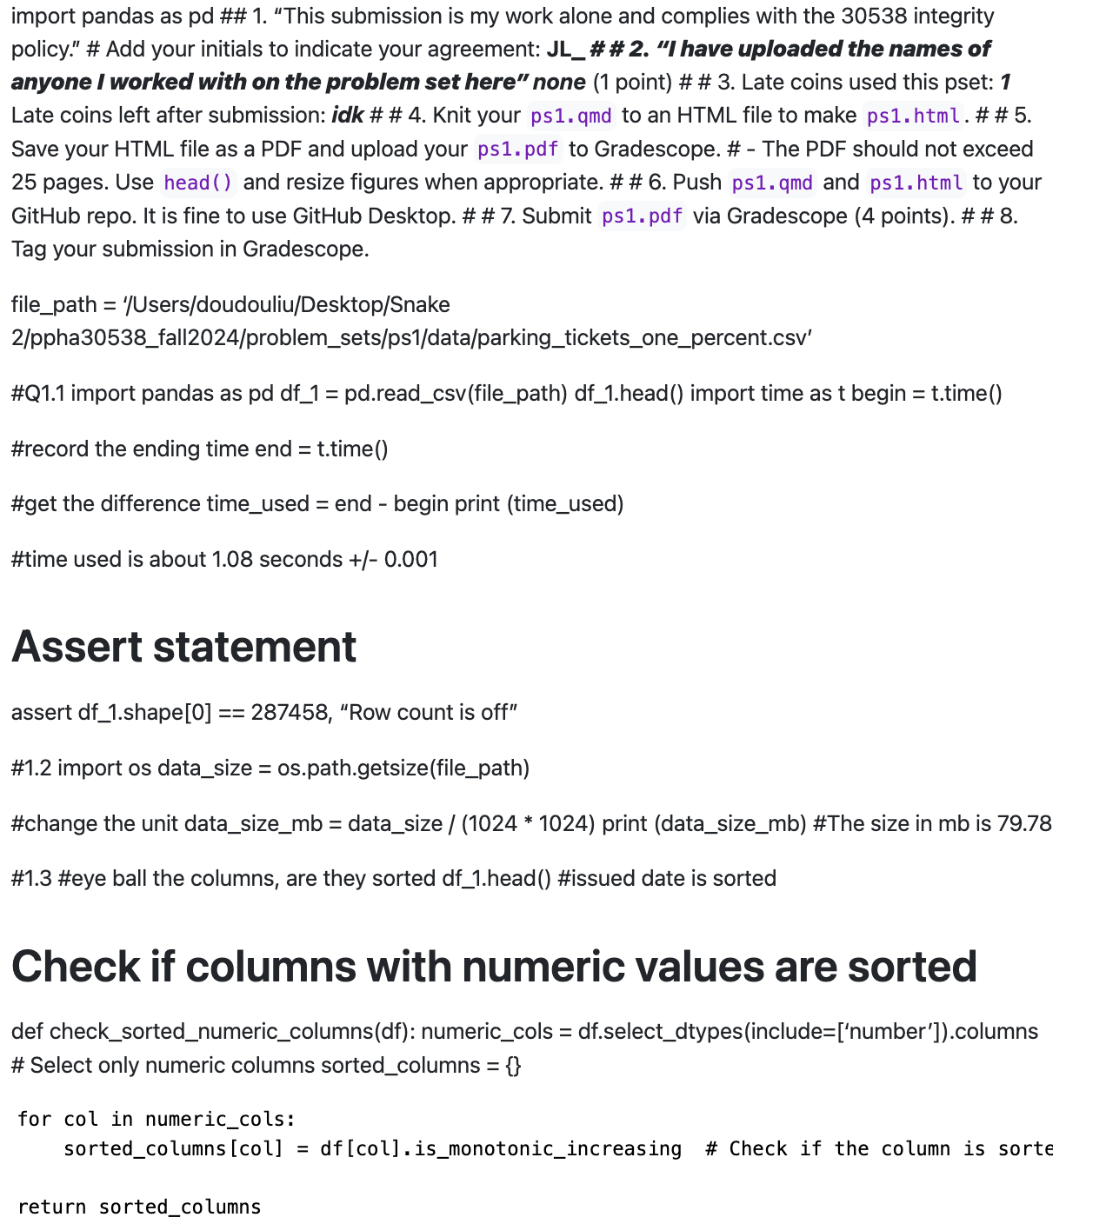

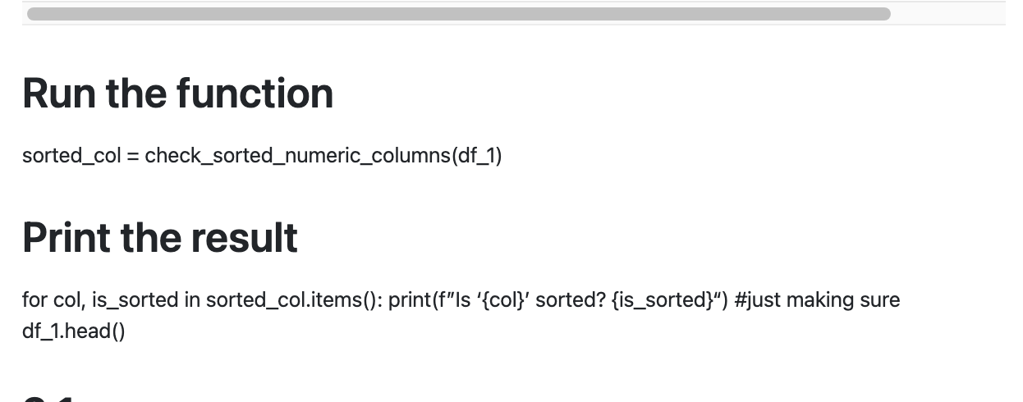

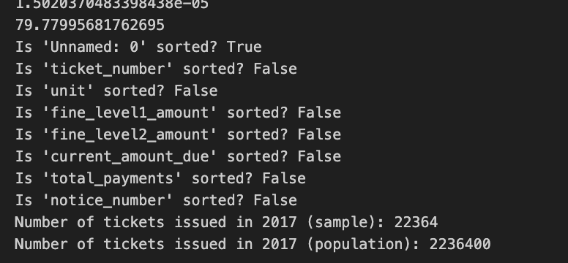

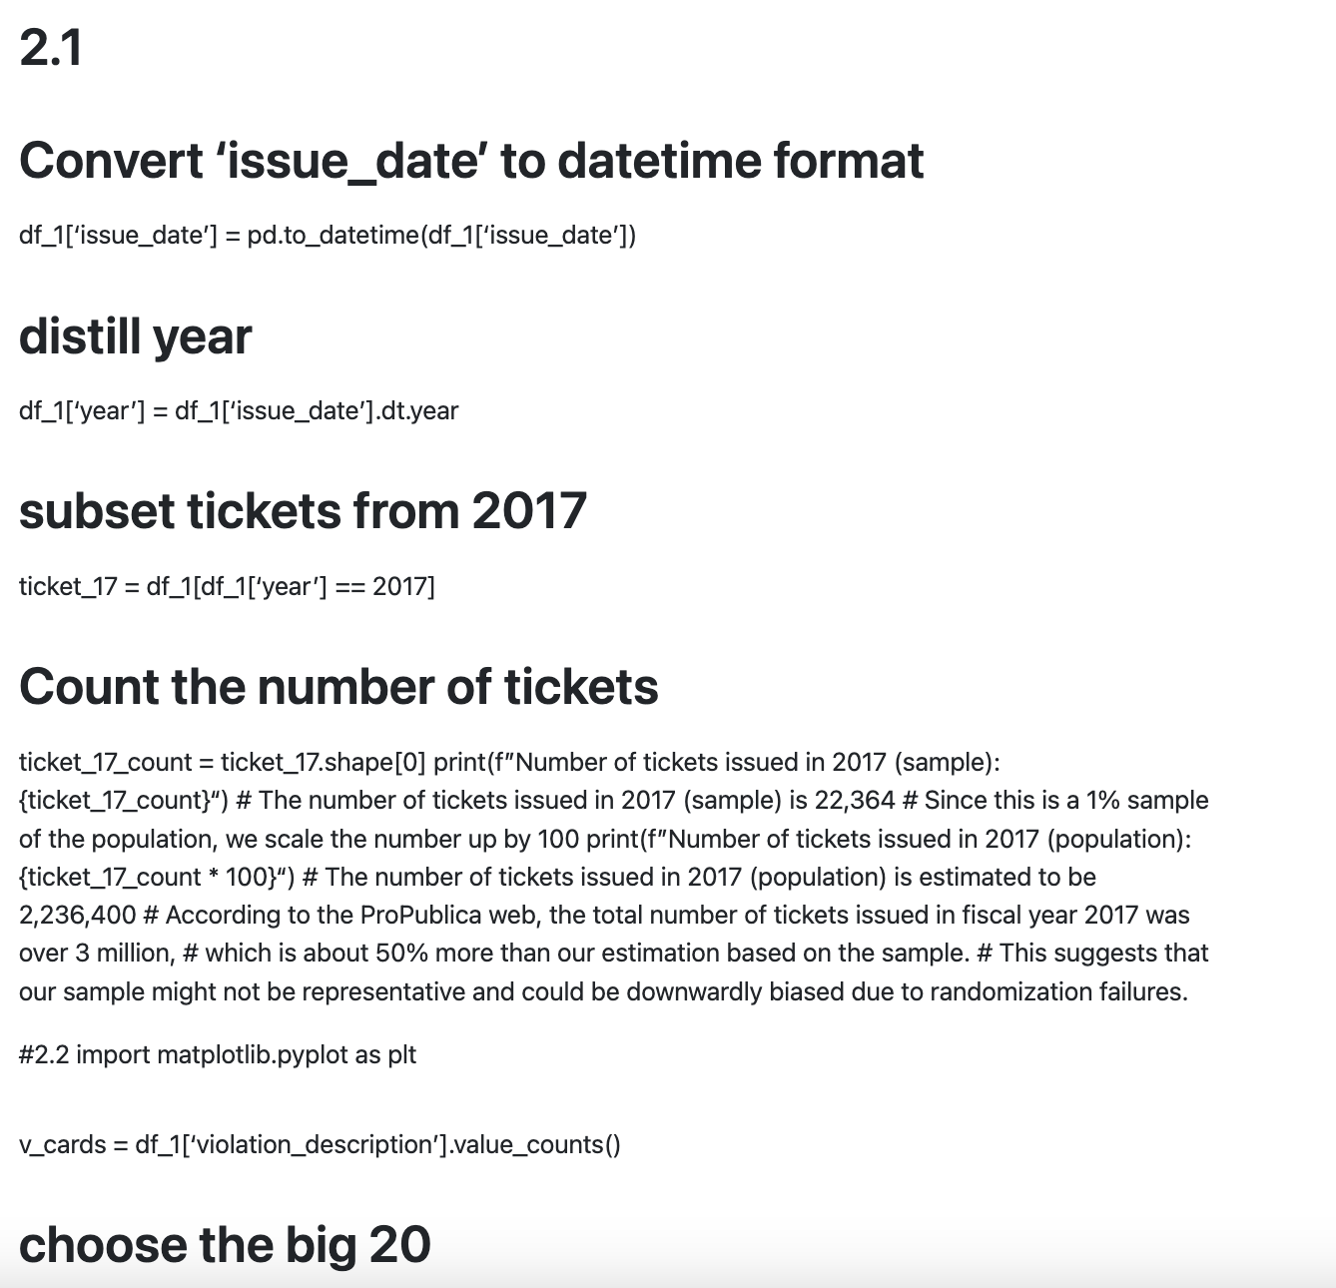

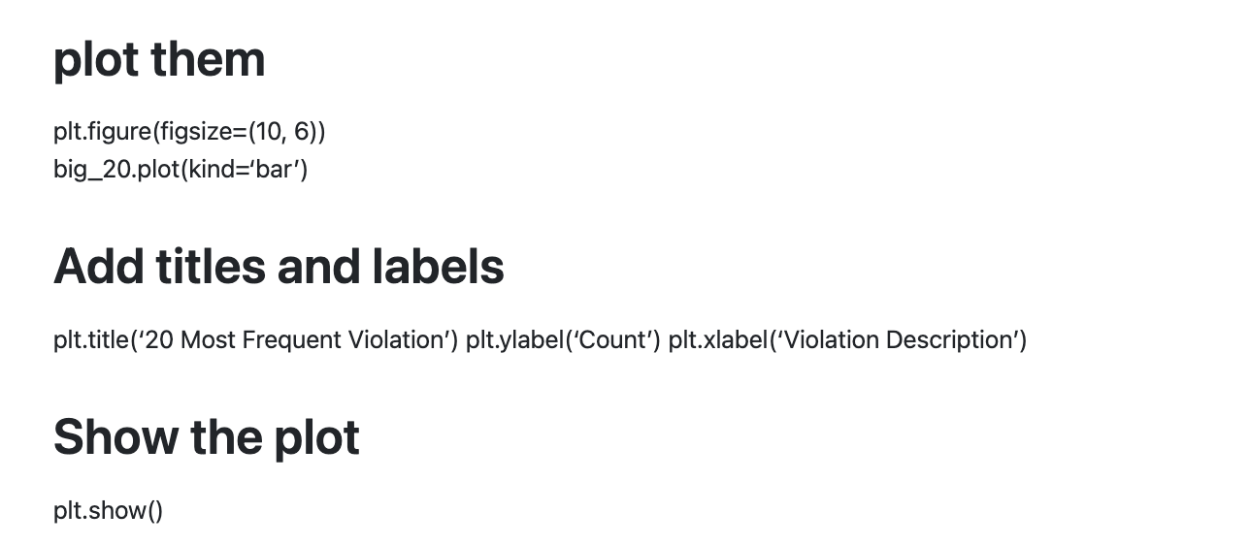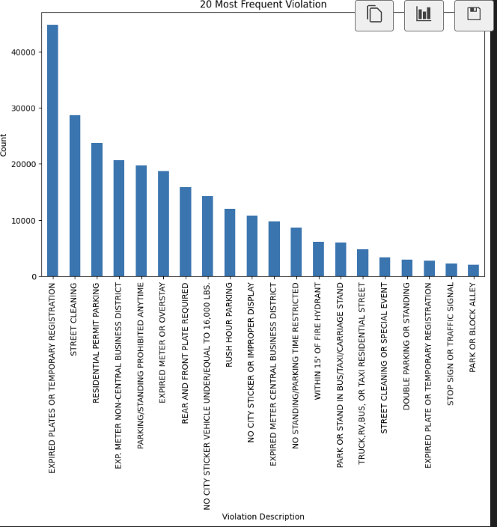

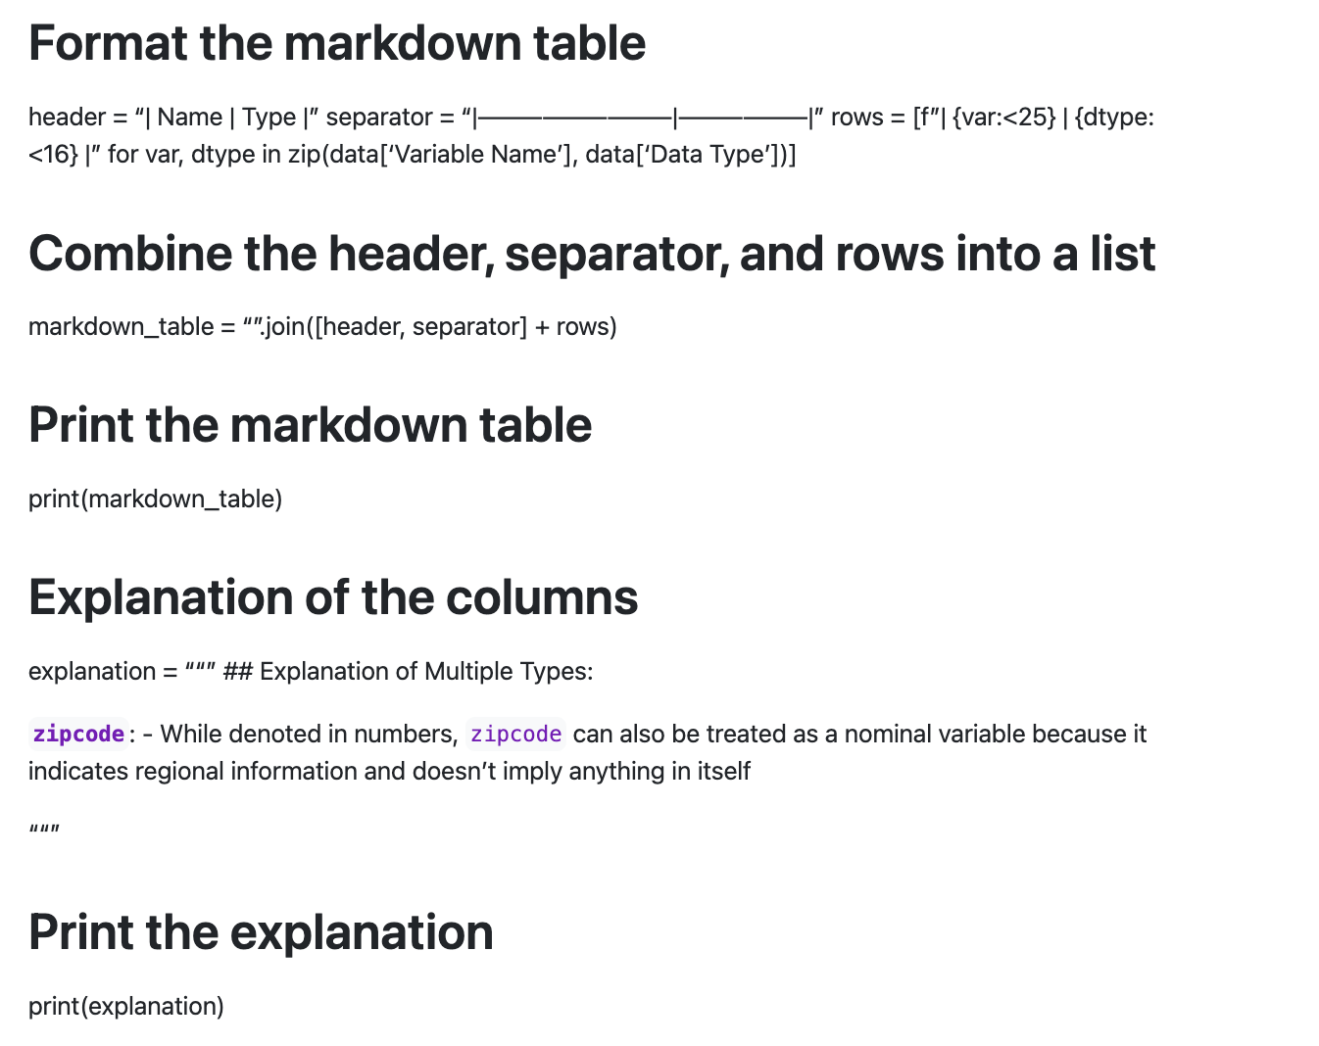

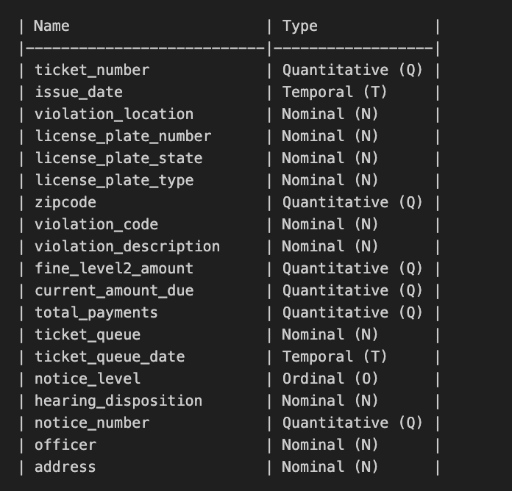

## Explanation of Multiple Types:

**`zipcode`**:

- While denoted in numbers, `zipcode` can also be treated as a nominal variable because it indicates regional information and doesn't imply anything in itself

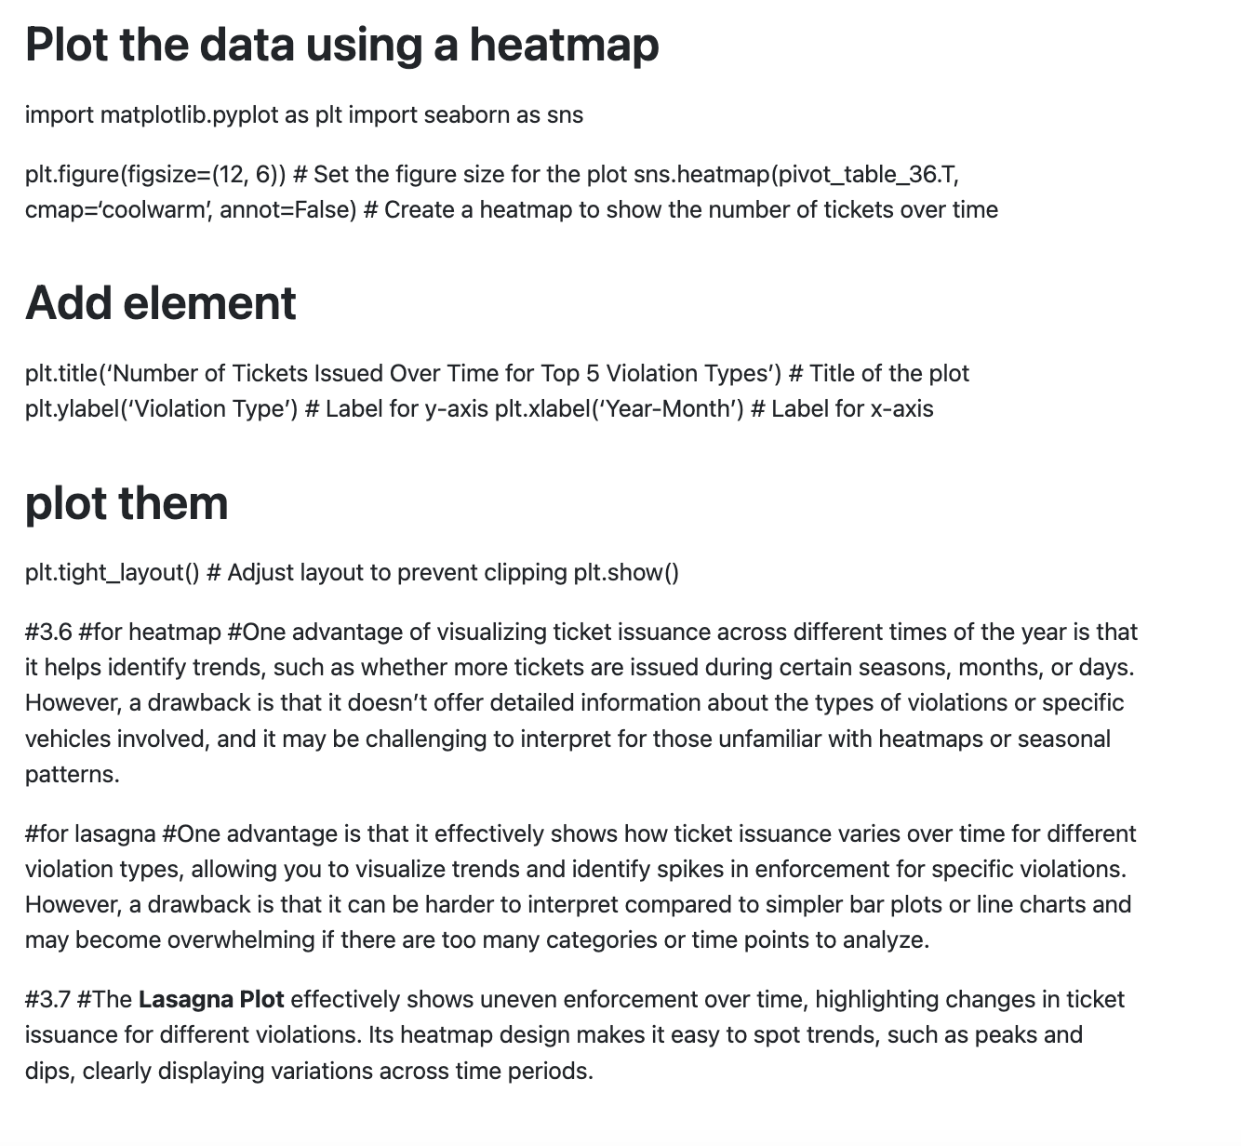

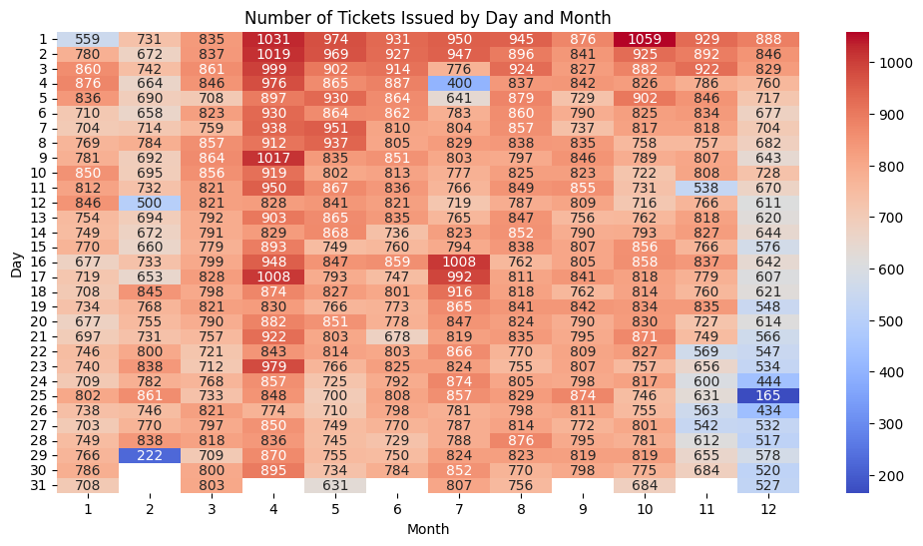

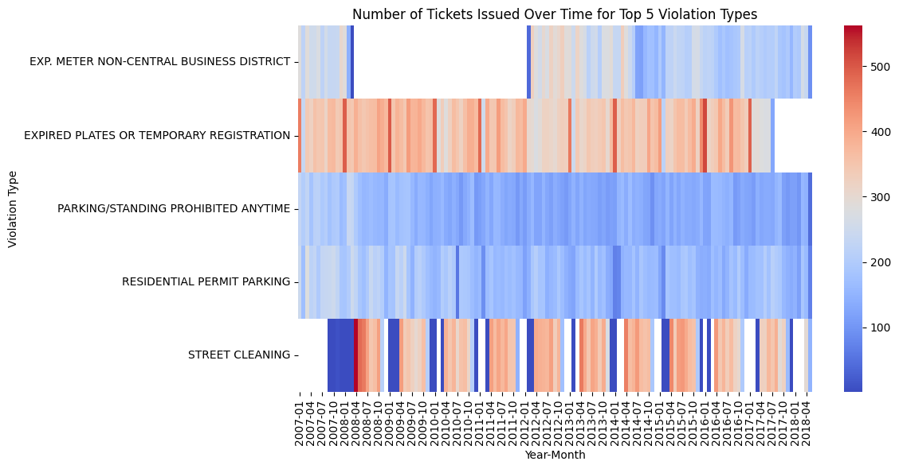

#3.6

#for heatmap

#One advantage of visualizing ticket issuance across different times of the year is that it helps identify trends, such as whether more tickets are issued during certain seasons, months, or days. However, a drawback is that it doesn't offer detailed information about the types of violations or specific vehicles involved, and it may be challenging to interpret for those unfamiliar with heatmaps or seasonal patterns.

#for lasagna

#One advantage is that it effectively shows how ticket issuance varies over time for different violation types, allowing you to visualize trends and identify spikes in enforcement for specific violations. However, a drawback is that it can be harder to interpret compared to simpler bar plots or line charts and may become overwhelming if there are too many categories or time points to analyze.

#3.7

#The **Lasagna Plot** effectively shows uneven enforcement over time, highlighting changes in ticket issuance for different violations. Its heatmap design makes it easy to spot trends, such as peaks and dips, clearly displaying variations across time periods.

